**Cost Per Click and Result with Click-Through Rate (Campaigns: 3, 10, 9, 4)**

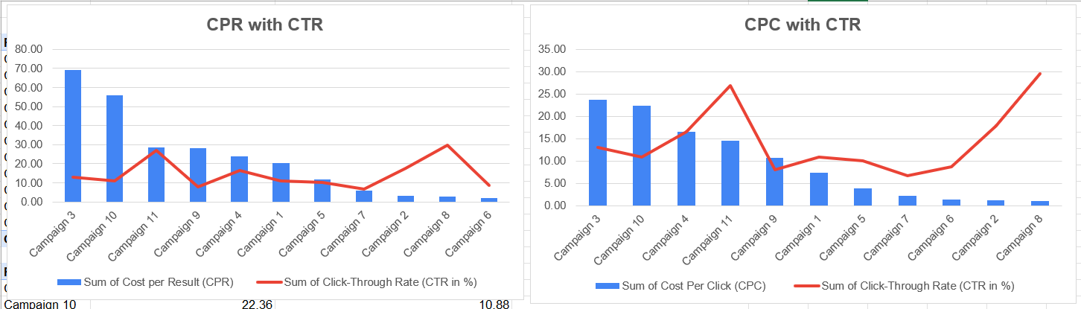

**Analysis of Poor-Performing Campaigns**

This analysis evaluates poor-performing campaigns based on high Cost Per Result (CPR), high Cost Per Click (CPC), and low Click-Through Rate (CTR).

**Campaigns with High CPR and Low CTR (CPR with CTR Chart)**

* **Campaign 3**
  + CPR: ~75
  + CTR: Low
  + The highest cost per result with poor click-through rate, making it inefficient.
* **Campaign 10**
  + CPR: ~60
  + CTR: Low
  + High cost per result with relatively low CTR.
* **Campaign 11**
  + CPR: ~40
  + CTR: Low
  + Expensive with low engagement.

**Campaigns with High CPC and Low CTR (CPC with CTR Chart)**

* **Campaign 3**
  + CPC: ~25
  + CTR: Low
  + High cost per click but low click-through rate, making it an ineffective campaign.
* **Campaign 10**
  + CPC: ~20
  + CTR: Low
  + High CPC with poor CTR, making it cost-inefficient.

**REACH VS CTR**

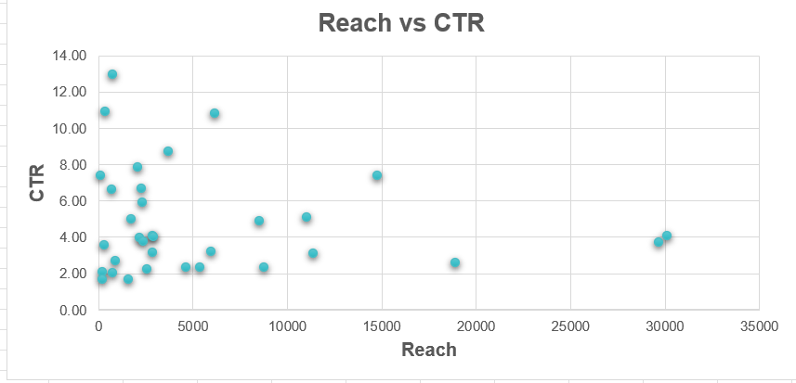

Higher reach does not improve the click-through rate, so reach should not be considered for this analysis.

**CPR and CPC with Unique Click Rate (Campaigns: 3, 10, 1, 9)**

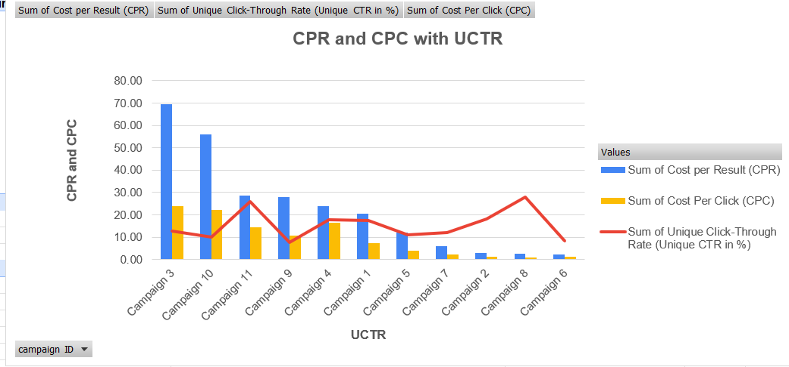

This analysis identifies poor-performing campaigns based on high CPR and CPC while having a relatively low Unique Click-Through Rate (UCTR).

* **Campaign 3**
  + CPR: ~70 (Highest)
  + CPC: Moderate (~15)
  + UCTR: Low
  + This campaign has the highest CPR, meaning it is very expensive to get results, making it a poor performer.
* **Campaign 10**
  + CPR: ~40 (Second highest)
  + CPC: ~15
  + UCTR: Low
  + This campaign is also costly in terms of CPR, making it inefficient.
* **Campaign 11**
  + CPR: ~30
  + CPC: ~10-15
  + UCTR: Low
  + This campaign has a high CPR and CPC, indicating poor performance.

These campaigns have high costs but do not perform well in terms of CTR, meaning they are not delivering good engagement for the money spent.

**Amount Spent with UCTR (Campaigns: 1, 3, 6, 7, 10, 9)**

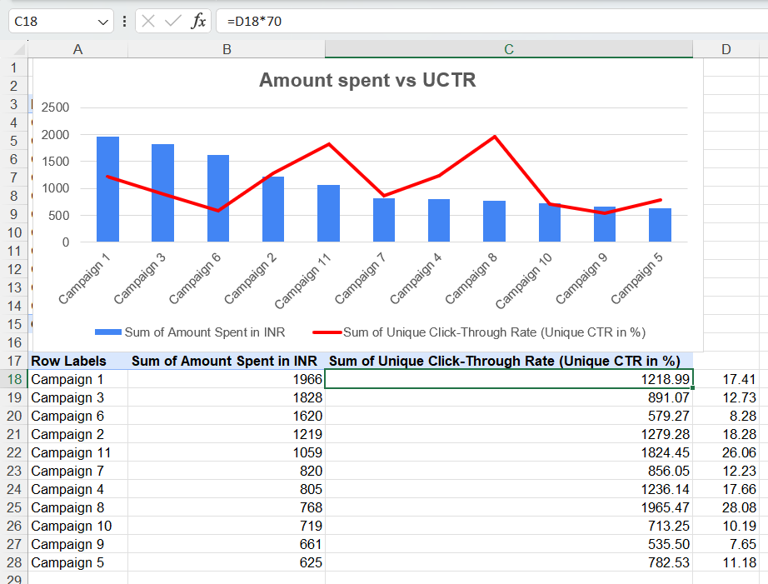

This analysis provides insights into the Amount Spent vs. Unique Click-Through Rate (UCTR) for different campaigns.

**Poor-Performing Campaigns**

* **Campaign 6**
  + Amount Spent: ₹1620
  + UCTR: 8.28% (Low)
  + Despite a moderate budget, the click-through rate is quite low, indicating poor engagement.
* **Campaign 10**
  + Amount Spent: ₹719
  + UCTR: 10.19% (Low)
  + Spent less but still has a below-average CTR.
* **Campaign 9**
  + Amount Spent: ₹661
  + UCTR: 7.65% (Lowest)
  + One of the worst-performing campaigns, with the lowest CTR and relatively low spend.

**Best-Performing Campaigns**

* **Campaign 8**
  + Amount Spent: ₹768
  + UCTR: 28.08% (Highest)
  + This campaign has the highest click-through rate, making it efficient.
* **Campaign 11**
  + Amount Spent: ₹1059
  + UCTR: 26.06% (Second highest)
  + Well-performing with a high engagement rate.
* **Campaign 2**
  + Amount Spent: ₹1219
  + UCTR: 18.28%
  + Another good performer with a decent CTR.

**Overall Insights**

* Campaigns 6, 9, and 10 are underperforming with low CTRs, meaning they are not driving much engagement despite spending.
* Campaigns 8, 11, and 2 are highly effective, delivering strong engagement for their spend.
* Campaign 3 has high spending (₹1828) but a mediocre CTR (12.73%), meaning it is not as efficient.

**BAR CHAR ANALYSIS CTR WITH CPR (**3,10,9,4,1**)**

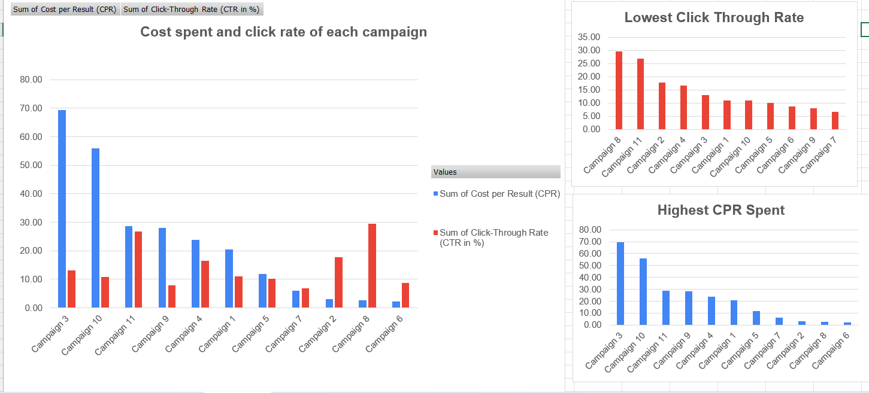

**Worst-Performing Campaigns**

* **Campaign 3**
  + CPR: ~70 (Highest)
  + CTR: Low
* **Campaign 10**
  + CPR: ~50 (Very High)
  + CTR: Low
* **Campaign 11**
  + CPR: ~30 (Moderate-High)
  + CTR: Moderate
* **Campaign 6**
  + CPR: Low
  + CTR: Very Low (~8%)
* **Campaign 9**
  + CPR: Moderate
  + CTR: 7.65% (Lowest CTR)

**FINAL RESULT**

Based on the analysis, the following campaigns should be discontinued due to high costs and low engagement:

**Campaigns to Discontinue**

* **Campaign 3**
  + CPR: ~70 (Highest)
  + CTR: 12.73% (Low)
  + Amount Spent: ₹1828
  + Very expensive with poor engagement.
* **Campaign 10**
  + CPR: ~50 (High)
  + CTR: 10.19% (Low)
  + Amount Spent: ₹719
  + High cost per result, low CTR.
* **Campaign 6**
  + CPR: Moderate
  + CTR: 8.28% (One of the lowest)
  + Amount Spent: ₹1620
  + Poor engagement despite a decent budget.
* **Campaign 9**
  + CPR: Moderate
  + CTR: 7.65% (Lowest CTR)
  + Amount Spent: ₹661
  + The worst engagement rate, meaning it is ineffective.

**Reason for Discontinuation**

* **High CPR**: These campaigns are costing too much per result.
* **Low CTR**: They are failing to engage users.
* **Budget Waste**: The money spent on these campaigns could be better used elsewhere.

These campaigns are inefficient and should be paused or stopped to save costs and improve overall performance.